Configuring GIthub in Windows

Install Putty

Putty download

<https://www.chiark.greenend.org.uk/~sgtatham/putty/latest.html>

Windows installer

MSI (‘Windows Installer’)

1. bit: putty-64bit-0.70-installer.msi (or by FTP) (signature)

Install Git

<https://git-scm.com/downloads>

Github website

<https://github.com/join>

Once you have created you account create a new repository.

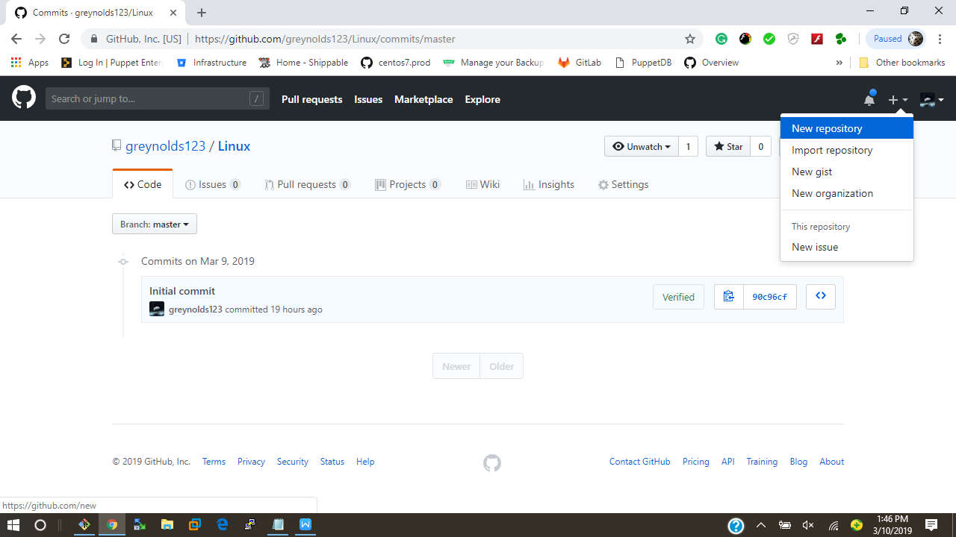

On your local PC or laptop create a directory. Or change into an existing directory.

While on the github website be sure to copy the clone repo information for https connection.

For https://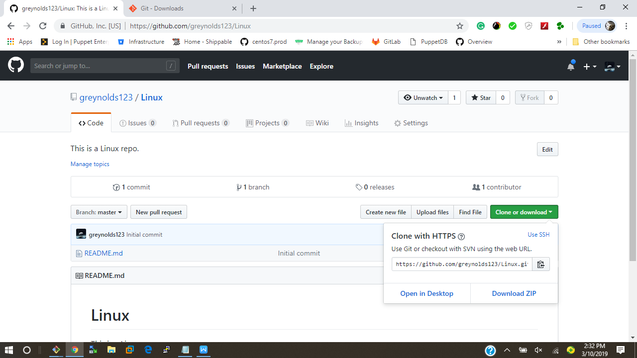

For ssh

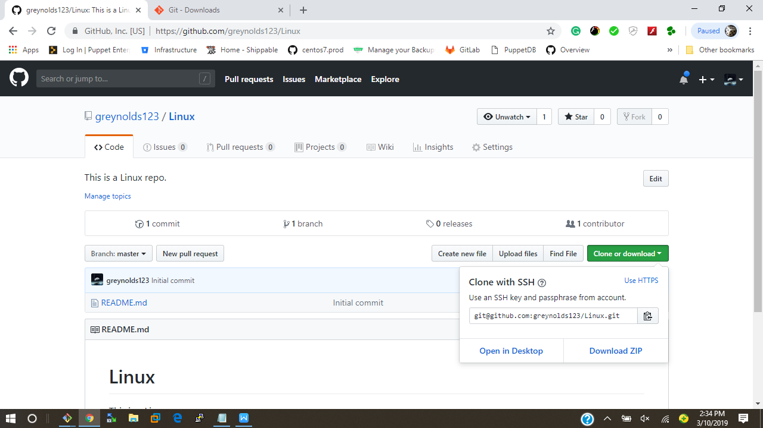

Assuming you have installed open git bash.

From the shell option: You will need to setup the initial repo

Once its open cd into that directory.

cd /c/Users/new/Desktop/USB-content/LinuxClass

Issue the following commands.

1. git init
2. git config --global user.name “YourName”
3. git config --global user.email [youremail@someplace.edu](mailto:youremail@someplace.edu)
4. git remote -v
5. if no repo are listed you will have to add them
6. git remote add NamedOfYourRepo YourBranch
7. git remote -v
8. git fetch repoName branchname
9. git status
10. git add -A
11. git commit -a -m “Initial commit”
12. git pull reponame branchname
13. Git push reponame branchname

After a successful commit open the GUI to manage your repo. The difference between using https:// abd ssh.

https:// -> prompts you for a username and password

ssh -> connects to your repo using the encryption keys and does not prompt you for a use name or a password.

To add your public key to you github website to use ssh. You can create one from the github site or add your existing ssh key.

